5G00DM05-3009/3010 Full Stack Web Development
Exercise 2
deadline: September 17, 2025, 23:59 EEST

Deviations from the instructions lead to XP reductions.

Support for Parts a) and b) can be found in the lecture material. Also, e.g., https://www.w3schools.com/react/react_props.asp can be useful.
For Part c), you have to get familiar with the course assignment instructions (published on September 12).

a)

Download the HTML file related to this exercise (ex02a.html) from Moodle. Keep the existing content intact, but add some new as instructed. Do not use external files, but keep the whole implementation in ex02a.html. Do not rename the file.
Add content to the file so that when it is opened using a browser, the page renders as presented in Figure 1. (The page should work when the HTML file is simply opened – without any need to set up any servers or anything like that.) Use the exact words and punctuation presented in the figure. | /1 XP
Each <Animal /> element in your code produces a visible row of text (as shown in Figure 1) so that if the values of the props are changed, the changes appear correctly in the presentation rendered by the browser, also. (Test this, but make sure the props have their original values when submitting your work, though.) | /1 XP
Always when and only when an <Animal /> element has the prop important defined with value true (as is the case with the second Animal), the corresponding row must be presented with boldface. (For the boldface effect, <b> or <strong> tags can be used – there is no need for styling for now.) | /1 XP
The number of legs affects the structure of the sentence properly as presented in Figure 1 (regardless whether the animal is considered important or not). Animal is implemented as a function component. | /1 XP

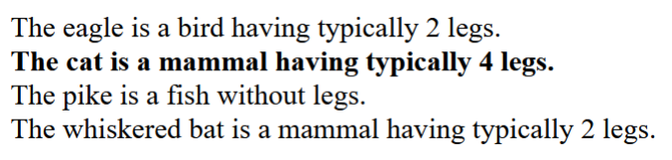
Figure 1. Your page should look like this (have these lines of text), when ex02a.html is opened with a browser. (Any special styling is not required.)

b)

Again, implement a React application using only a single HTML file. You can use, e.g., the skeleton file provided for a) as a starting point and modify it. Save this file as ex02b.html.
Implement there React components ElementBlock and ElementBlockRow (with these exact names) and use them in such a way that when the file is opened with a browser, it is rendered (roughly) as depicted in Figure 2. (This should be accomplished by letting your root element render three elementBlockRows and passing them suitable props.) | /1 XP
- ElementBlockRow takes care of rendering possibly several ElementBlocks on a single row (and single row only). | /1 XP
- Each ElementBlock renders a string and a button. (Separately and not several!) | /1 XP
- On each row, the numbers on the buttons of the ElementBlocks count from 1 up to the maximum number of ElementBlocks defined to be presented within the row. You should pass the necessary information (i.e., strings and numbers to show for ElementBlocks and maximum number of ElementBlocks for an ElementBlockRow) to the components using props. | /1 XP

Hint: you can, e.g., add JSX elements in an array, and let a React component to render this whole collection of elements by using the array variable – remember the curly braces syntax! For each element within an array, you must define a "key" attribute with a unique value within this set of elements. (In practice, your application may work correctly even without the keys, but you should define them anyway for the internal needs of React.) For more info, see, e.g., https://react.dev/learn/rendering-lists. (A browser warning for missing keys → reduction of 0.5 XP.)

Remember that you should not nest component definitions – define all the components on the same level in your code.

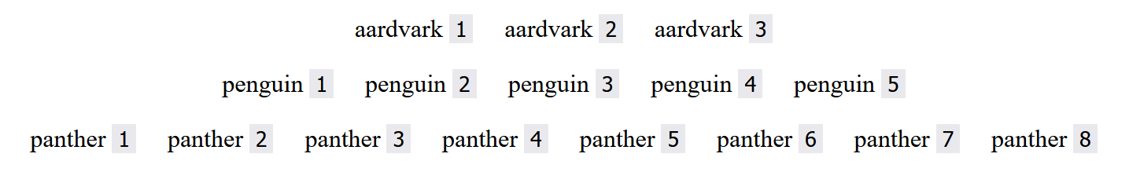
Figure 2. Your page should look like this (at least roughly – the texts and numbers must match), when ex02b.html is opened with a browser. There are three ElementBlockRows each having different numbers of ElementBlocks. (For example, the middle ElementBlockRow has got the number of required ElementBlocks, 5, in props and thus renders 5 ElementBlocks passing proper props to each of them so that they are rendered correctly.)

c)

Get familiar with the course assignment instructions (published separately in Moodle on September 12) and start planning your assignment application. Fill out this table.*

See requirements of Module A (and Terms and Abbreviations). Which logical views are you planning to implement? Describe briefly the content/purpose for the three most important of them.
- Completed tasks | /0.5 XP
- Ongoing tasks | /0.5 XP
- Waiting to start tasks | /0.5 XP
Which features to be implemented do you see the most challenging?
Why?
 | /0.5 XP
Mention at least one question you have concerning the instructions – what is unclear? (If everything is clear, mention it here explicitly.)
 | /1 XP

* N.B. The answers should not be, e.g., about Part a) of this exercise, but really about the course programming assignment instructed separately. Based on your plans reported here it should be clear that you have read the instructions, so do not describe some arbitrary webshop application or anything that has nothing to do with the instructions...

Submission
When ready, save and submit this file (still in ODT format) along with all the code files related to this exercise (i.e., ex02a.html and ex02b.html) in the Moodle submission area. The files should be added separately, not, e.g., bundled into a .zip file.

Totally: /11 XP

